Word Document for # 17 in Revelation Study

Sunday:
- What stands out to you from the above and why?

Monday: Another Mighty Angel
2. Read Revelation 10:1-4 and describe the angel.
3. In Mystery Explained, read the section under Vision Give Between the 6th and 7th Trumpets.
A. John is being recommissioned to prophesy -- what does this prophesy concern?
B. Why might the relationship between believers and unbelievers grow more intense during this time?
4. Under John Recommissioned As A Prophet read up to "And the Angel" and see if you can then answer:
A. What are some of the ways this angel is closely linked to Christ?
B. What does the little scroll deal with (look particularly at last sentence in this paragraph)
C. What does the angel setting a foot on the sea and on the land signify? (Joshua 10:24-26 might help)
D. Name a trial you are facing right now and the hope God's sovereignty gives you.
E. With what is thunder associated?
F. Did anything else stand out to you from this section?

Tuesday: No More Delay!
God has been so patient, giving men time to repent, but it will not always be so. Each person has the span of his life, but in the last days, that life may be surprisingly cut short. Though I don't know how effective billboards are that warn the end is near, we know we are called to be witnesses, to have eyes to see whom God may be wooing, and to be prepared to give an answer for the hope within us. I do think it is getting harder, because of the hostility against us, but God still opens doors. The most fertile fields are children and those going through a crisis, and we need to sow our seeds!
5. When was the last time you bravely shared your faith? Hoping for some encouraging stories!
6. Read Revelation 10:5-8
A. In verse 6, what does the angel say?
B. What will happen, according to verse 7, when the 7th trumpet is blown?
C. What is John told to do in verse 8?
7. Read from the BOLD And the angel I saw standing to the vision resumes and share your thoughts.

Wednesday: Eat The Scroll
I loved Eugene Peterson's book "Eat This Book," for he gives ideas on how to do that, how to really chew and digest God's Word. And he said:
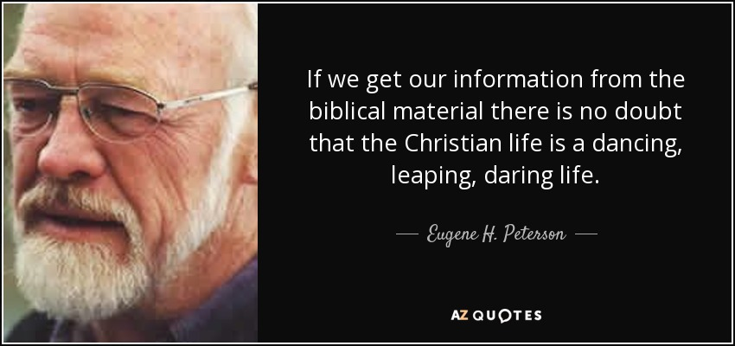
8. Read Revelation 10: 9-11 and share what you see, learn, and how you could apply it.
9. 2 Corin. 2:15-16 adds light to why this Word is both sweet and bitter. What do you see?
10. Read the rest of Campbell's section up to spiritual warfare during the church age and share any comments.

Thursday/Friday Sermon
11. I found this chapter challenging until I listened to this sermon. Please watch Matt Menzel and share the main points and your thoughts.
http://wchurch-sermons-2016.s3.amazonaws.com/main/2016-03-20_Revelation10_MattMenzel.mp4

Saturday
12. What is your take-a-way and why?

